Research
Thermal properties of solids.
Blumenau M., 17.12.2020
Table of contents
Abstract 1
Theoretical information 1
Resistivity as a function of temperature 1
Heat losses and radiation 1
Thermal conductivity of a metal 2
Equipment 2
Description of the installation 2
Results and data analysis 3
Measurement uncertainty 6
Summary 6

Abstract
Thermal properties of solids are investigated. Analysis of the resistance of a thin wire gives information about changes of the conductivity in metals due to temperature change. Results are used to calculate heat loses. As a part of the experiment, thermal conductivity of a copper tube is measured.

Theoretical information

Resistivity as a function of temperature
All the materials used in this work are, under normal conditions, classical examples of solid bodies - metals. Their resistivity depends linearly on the temperature according to the following law:

The resistivity can be found by Ohm's law:

Heat losses and radiation
According to the Newton-Richman law, the normal component of the heat flow through the wall of a solid is defined as:

The Stefan-Boltzmann law is used to determine the thermal losses due to thermal radiation:
where the Stefan-Boltzmann constant, is the emissivity of the body.

Thermal conductivity of a metal
For accurate results the thermocouple needs to be calibrated. We used the expression:
, where is measured in and in
If we consider that we don’t heat the pipe significantly, we can write that the output power is . Because our pipe is symmetrical, have of the heat will move to each of the sides.
According to the Fourier's law:
. [1]

Equipment
Wire from the test material (presumably tungsten), thermal paste KPT-19, thermocouple, aluminum can, 2 multimeters, shunt, computer with LabVIEW program, boiler, power supply, copper pipe, insulation.

Description of the installation
Each part of the experiment had its own installation. The first part was to find out how resistivity changes with temperature. We used the following scheme:
The second part involved measuring heat losses, for that was used a LabView program, that recorded temperature, power consumption, etc. Scheme is illustrated on the picture below.
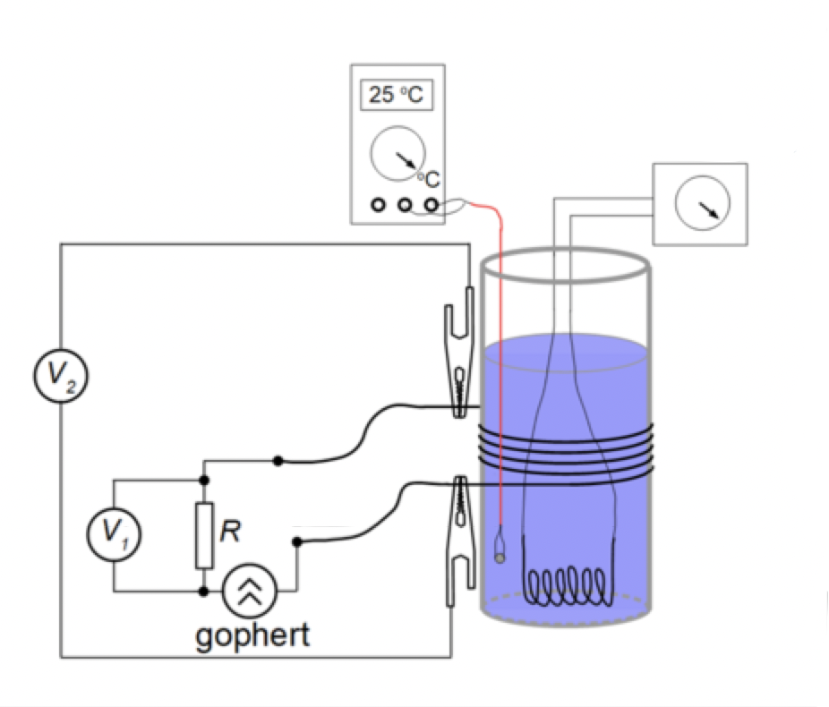Illustration 1: Scheme 1
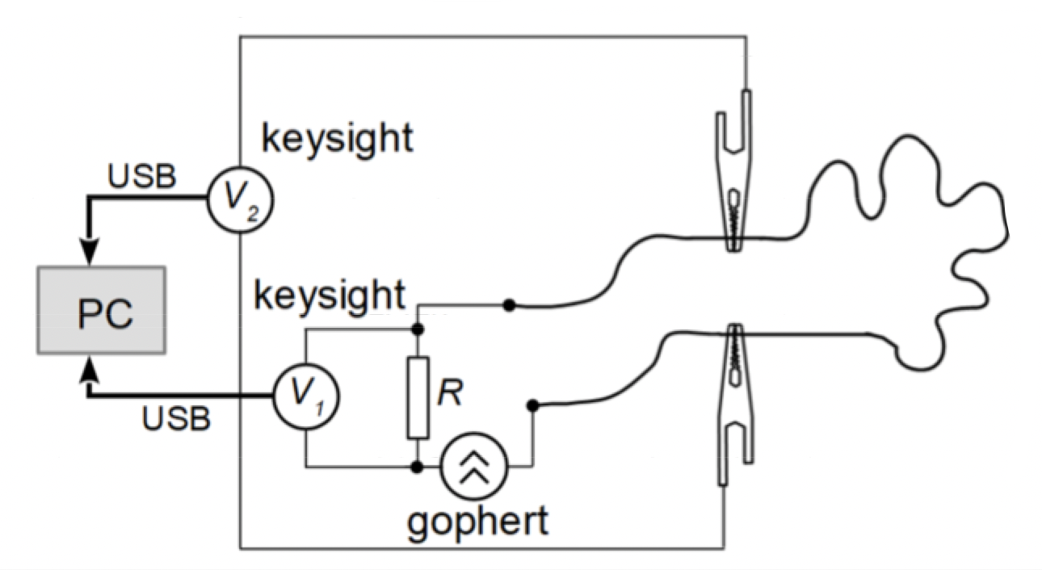Illustration 2: Scheme 3
We connected a DC power source to the A'B ' section. For thermal insulation we put foam around it. The entire structure is symmetrical. The current flowing in the tube heats it up, and the heat exchange with the environment is minimized due to thermal insulation, so the heat is distributed through the tube and goes into the air only at the ends of the tube. We assume that the resistivity of the tube does not change. After some time, we measure temperature inside the tube with a thermocouple.
[1]
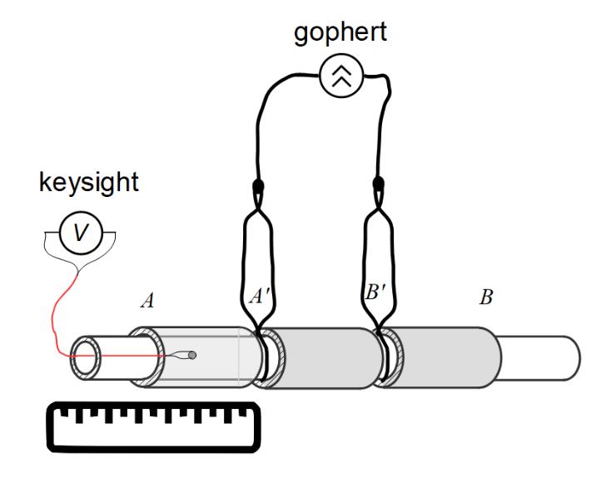Illustration 3: Scheme 3

Results and data analysis
The first part consisted in finding the correct temperature coefficient of resistance. As shown on the illustration 1, two voltages were registered. Results were as following:
T, K | 290 | 294 | 298 | 306 | 312 | 322 | 331 | 342 | 349 | 359 | 367
 | 0.250 | 0.253 | 0.254 | 0.252 | 0.252 | 0.254 | 0.252 | 0.252 | 0.252 | 0.252 | 0.251
 | 42.4 | 43.45 | 44.36 | 45.46 | 46.31 | 47.75 | 48.91 | 50.44 | 51.31 | 52.57 | 53.84

Also, the length of the wire was, its diameter and the shunt resistance was . Using all of the presented data, we get:
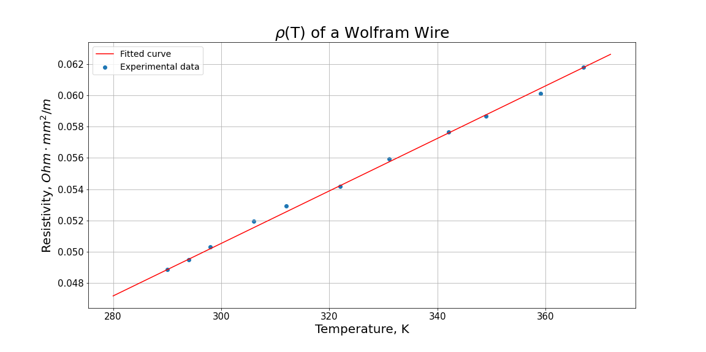Illustration 4: Resistivity of a wolfram wire as a function of temperature
And .
The second part included measuring emissivity and heat transfer coefficients of the solid. Using a LabView program, we get data about total consumption and temperature of the sample. Thus:
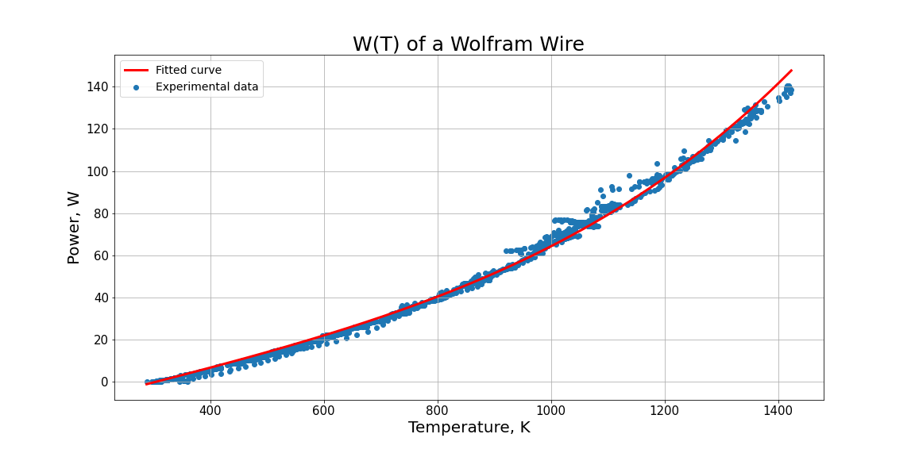Illustration 5: Consumed power as a function of temperature
We got , . As for the heat capacity of the material:

The last part of the experiment involved measuring thermal conductivity and resistivity of a copper tube. At first, one has to calibrate the thermocouple. That can be done by measuring its voltage using a multimeter and having a separate thermocouple of the same type connected to a tester. We got:
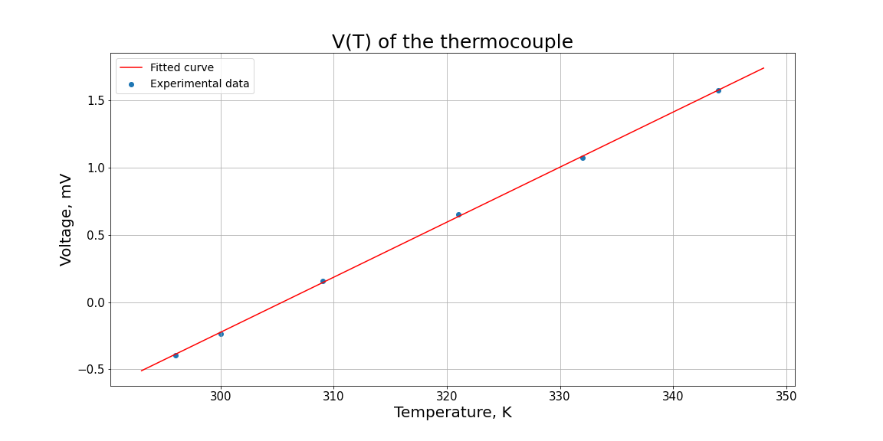Illustration 6: Voltage on the thermocouple as a function of temperature

Then we measured the resistivity using the same scheme as for the wire in the first part. All data is presented in a table:
 | 0.177 | 0.256 | 0.403
 | 0.133 | 0.190 | 0.292
 | 0.0176 | 0.0174 | 0.0170

After some time, when temperature stopped changing, we measured it along the tube from the inside. Results are:
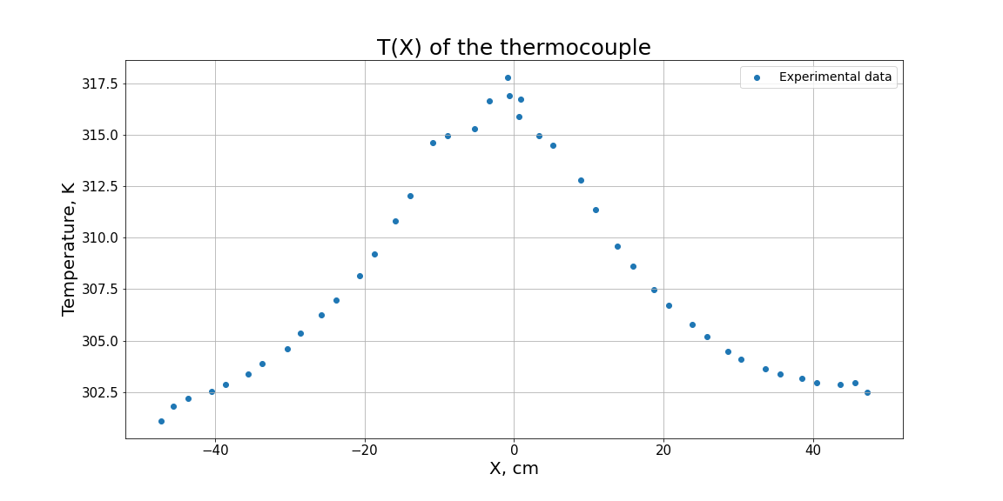
where 0 is the center of the tube. Thus, we get .

Measurement uncertainty

Summary
When compared with the tabular data, one can see that our result differ:
 |  |  | с
Tabular | 0.00441 | 0.032 - 0.35 | 134 - 142 | 401 | 0.0171
Experiment |  |  |  |  | 0.0173

There are some reasons for that. First of all, we don’t know how pure our samples are. Second, our insulation might have been leaked and that had an effect on our thermal conductivity.

Bibliography
[1]: Heat capacity and conductivity, unknown author, 2020

